File Handling- Read, Write, Append

1. Write to file : In this 1st option, file will be created and some string will be inserted in it.

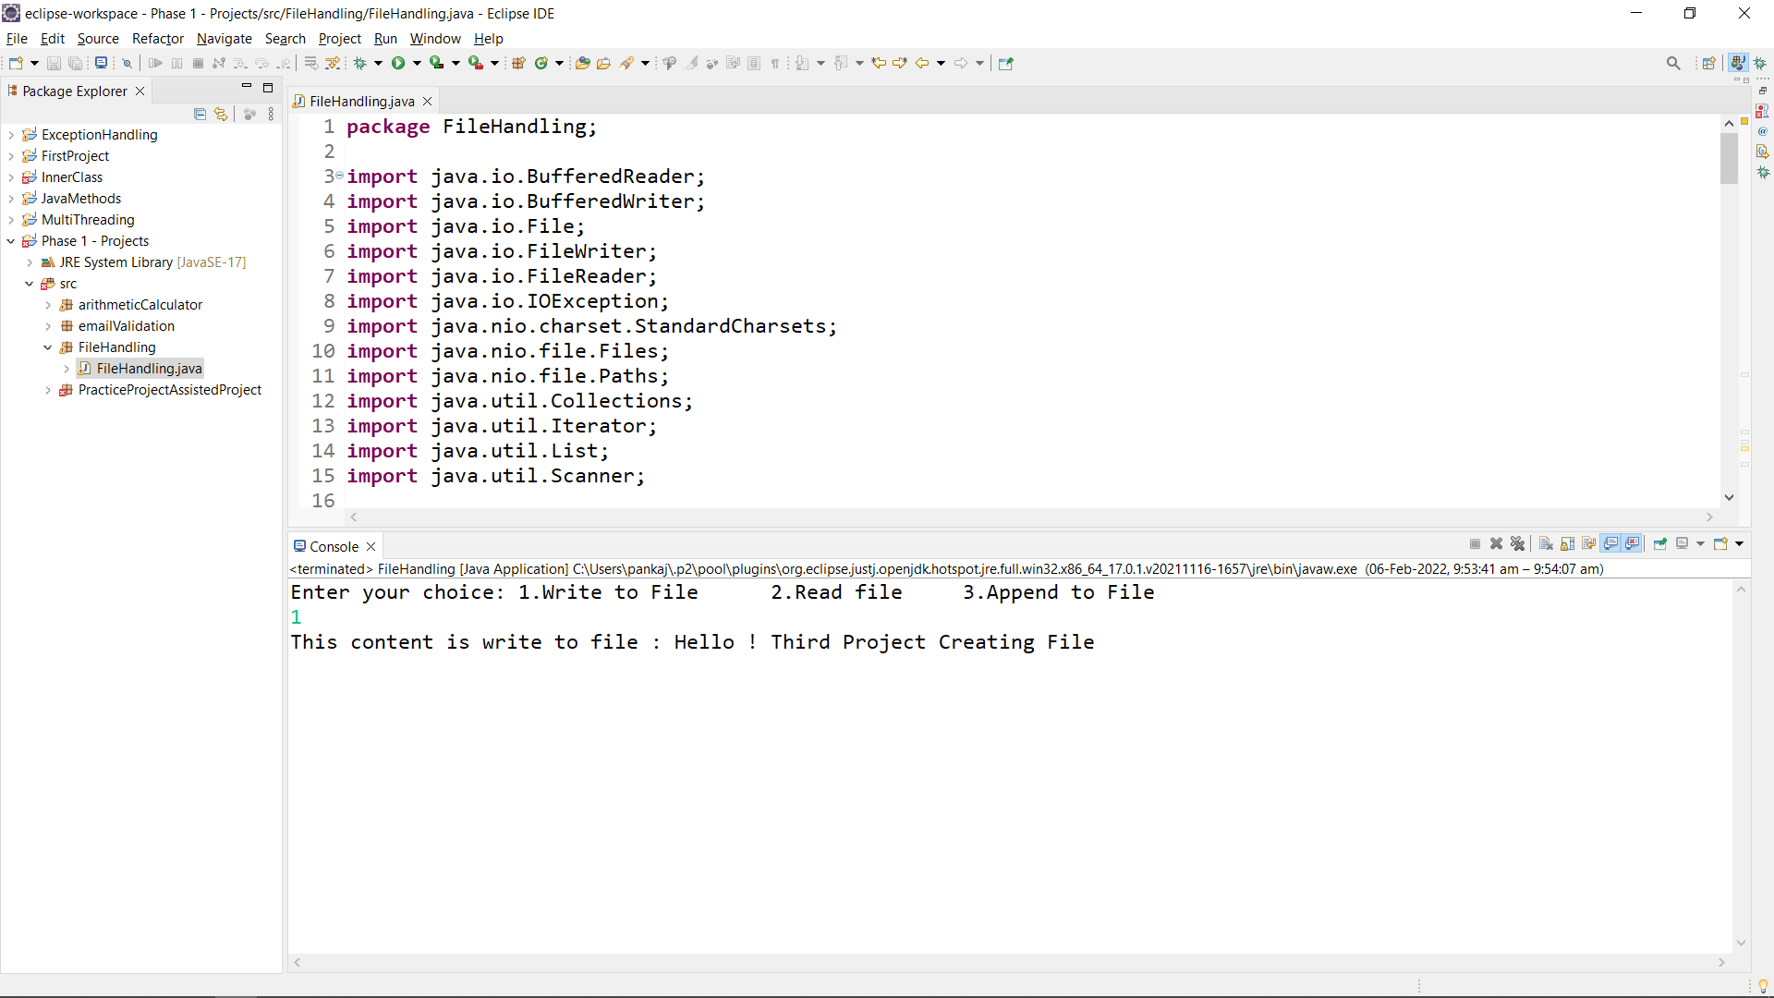

1. Reading a file

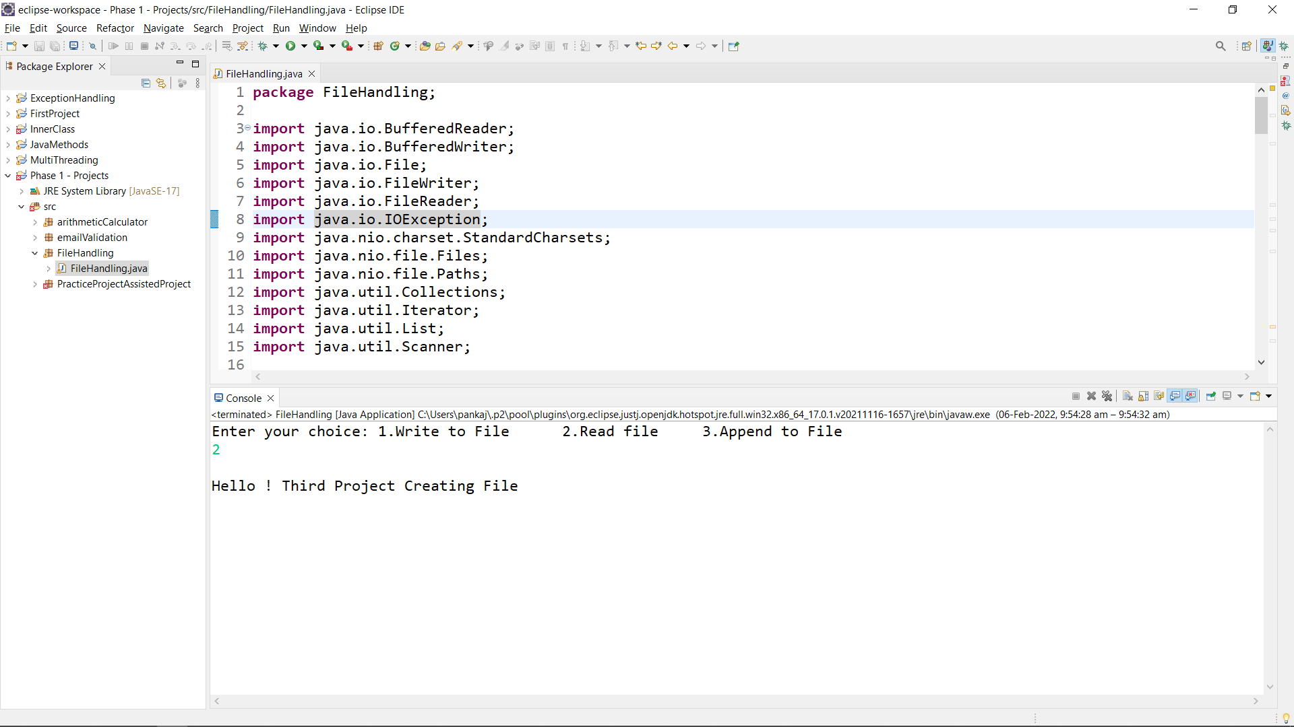

1. Appending a string to file : Taking input string to file and appending the same.

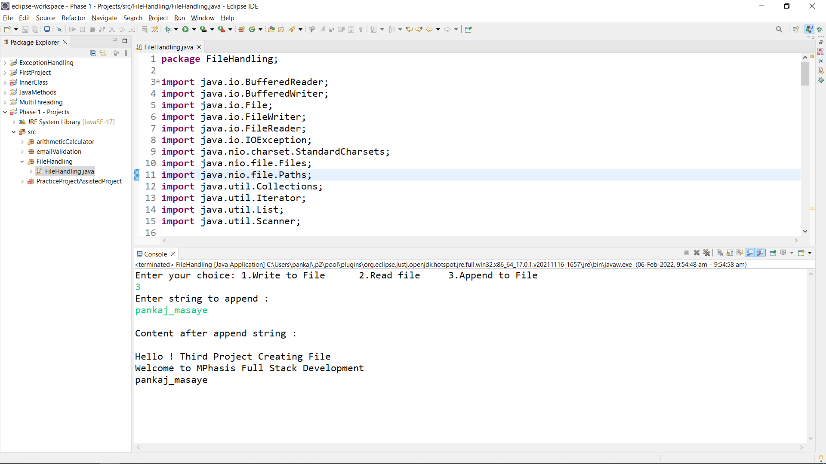

1. Again reading a file to check if appended string is valid or not.

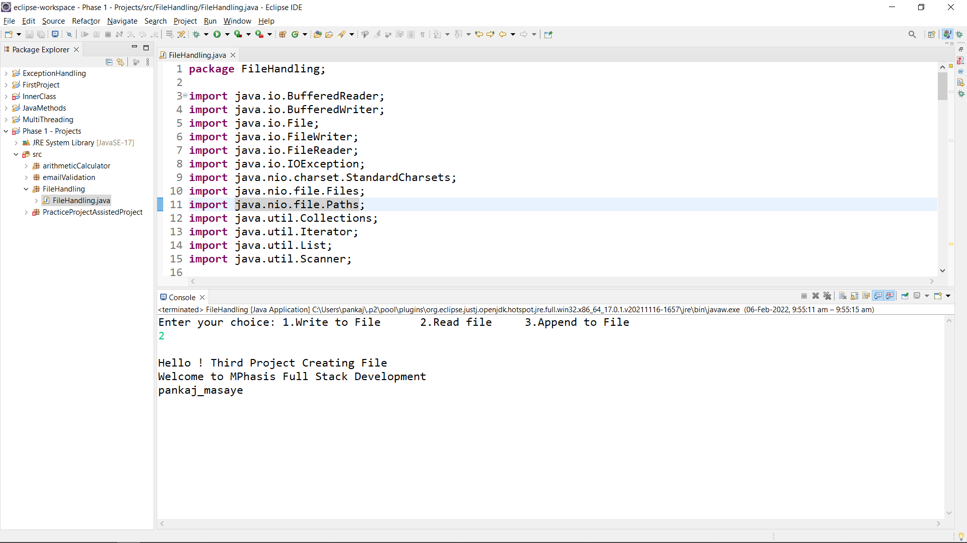

1. Appending another string to file.

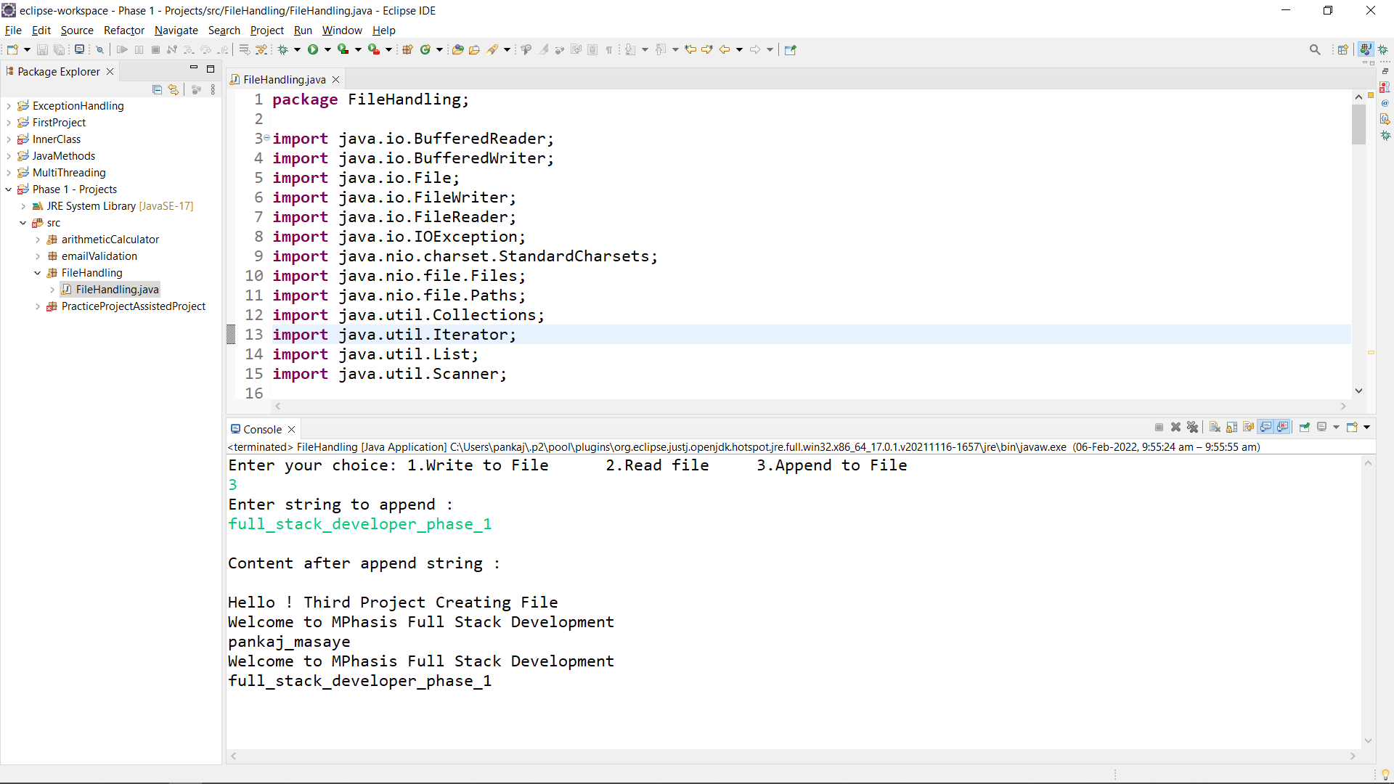

1. Reading again to confirm the appended file

